TEACHER NOTES FOR EXPLORING ELECTRICITY

Introduction
Electricity: a form of energy resulting from the existence of charged particles (such as - electrons and + protons), either statically as an accumulation of charge or dynamically as a current flowing
- Charges and fields simulation: https://phet.colorado.edu/en/simulation/charges-and-fields
- Electric field hockey simulation: https://phet.colorado.edu/en/simulation/legacy/electric-hockey
- Static electricity with balloons
- Balloon simulation: https://phet.colorado.edu/en/simulation/balloons
- Static electricity with Vander Graff generator
- Static discharge simulation: https://phet.colorado.edu/en/simulation/travoltage
- Dynamic electricity with household wiring
- Ohm’s Law simulation: https://phet.colorado.edu/en/simulation/ohms-law
- Circuit simulation: https://phet.colorado.edu/en/simulation/legacy/circuit-construction-kit-ac

Relevant ICP Content Standards
Standard 8: Electricity and Magnetism

Relevant Physics 1 Standards
Standard 8: Simple Circuit Analysis

Relevant Physics 2 Standards
Standard 4: Electricity
Standard 5: Simple and Complex Circuits

Included Materials
- 12 electrical stations made of 2x4 wood with 2 electrical boxes installed on each
- 1 complete electrical station for demonstration
- 12 outlets/receptacles with covers
- 12 switches with covers
- 12 sections of about 3 ft wire
- 12 plugs
- 45 wire nuts
- 12 screw drivers
- 12 electrician’s tools
- 2 outlet testers
- 1 roll of electrical tape

ACTIVITY: EXPLORING ELECTRICITY

Introduction
It is difficult to imagine a world without lights, computers, stereos, or microwave ovens. A few hundred years ago, these items had not yet been invented. Even if they had, there wouldn’t have been any place to plug them in! When electricity was originally used for practical purposes, it was used for communication in the form of the electric telegraph and the telephone. Petroleum and paraffin lamps were still lighting homes until the late 1800s, when Thomas Edison developed the light bulb. Edison was also responsible for the first central power station and many power companies still bear his name. If you compared today’s power requirements to what was needed 100 years ago, you would be shocked. Today, power plants located all over the country generate electricity with huge turbine generators that are driven mostly by fossil fuels, nuclear energy, or hydropower. Many factors contribute to our growing electricity demand.

Electricians
The skills that you will gain from this lesson are invaluable. Homeowners spend large sums of money to hire craftspeople to do the same jobs you’ll learn in these lessons. Regardless of whether or not you pursue one of these fields professionally, you will benefit enormously from the skills you acquire in these hands-on experiences. You may someday have the ability to build an addition on your house or do all of your own electrical wiring. The possibilities are endless. There are plenty of job opportunities relating to the areas covered in the Residential Workshop Series. For example, renovation is becoming an increasingly larger percentage of construction in the United States. Imagine the enormous satisfaction a carpenter gets after restoring the original details of a stylish Victorian home. Electricians have a thorough understanding of electricity. They are very familiar with electrical equipment as well as the safety requirements for performing specific tasks. Electricians can receive some of the highest wages and best benefits of all the construction-related trades. Whether you enroll in a union apprenticeship program or learn by doing, being a carpenter, plumber, or licensed electrician can be a very rewarding occupation. You may even decide to go into business for yourself. If you work hard and have patience and determination, your business can become very successful and lucrative.

Science
Electrical systems can seem like a confusing mess of wires, connections, and hidden boxes. If you use common sense and take the necessary precautions, you can easily and safely handle most home wiring projects. Working with electrical wiring can be intimidating because of the potential for serious injury. As you learn more about electricity and wiring, you will become more confident. Let’s begin by going over the fundamentals of electricity. AC (Alternating Current) changes constantly from zero to 120 volts and then back down to zero to minus 120 volts. This cycle repeats itself 60 times every second. In terms of your electric service, this is referred to as 120VAC 60Hz. The flow of electricity through a wire is comparable to the flow of water through a pipe. However, in order for electrical current to flow, a return path must be provided. Just as un-pressurized water is drained away from a house, current must flow back through a neutral wire, which carries no voltage. Just as pipe with a large diameter can carry a greater volume of water than a narrow pipe, a large wire can carry more current than a small wire. The amount of current flowing in a circuit is called amperage. Most household circuits have a capacity of either 15 or 20 amps. Wattage is a measurement of how much electrical power a device consumes. It is the rate at which current is converted into other forms of energy, such as light, heat, or motion.
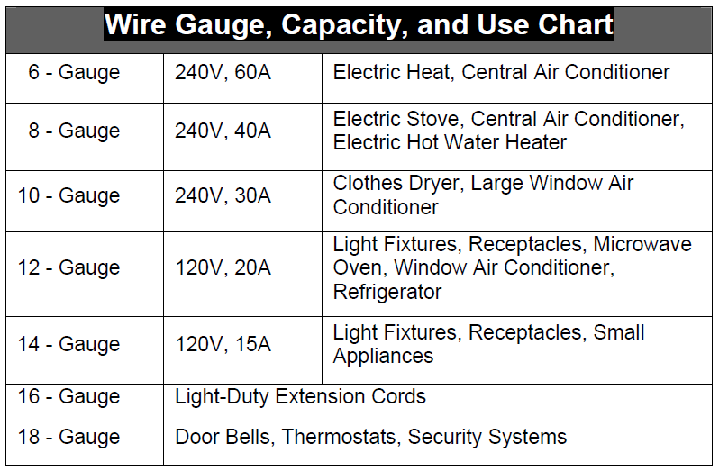
The hot wire has black or red insulation and carries current from the power source.
It is connected to “gold” screws.
The neutral wire has white or gray insulation and returns current to the power source.
It is connected to “silver” screws.
The ground wire is usually bare copper or green insulated and is used to carry current to the earth in case of a short circuit.
It is connected to “greenish” screws.

Safety
As with any project, safety should always be your primary concern. Always use common sense and exercise caution whenever you work with electrical wiring. Always remember to shut off the circuit breaker and test the circuit for power before you begin working. Never turn the power back on until the job is completed. Other safety precautions include:
- All switches, receptacles, metal boxes, and light fixtures should be connected to a ground. This allows any errant current to return to the service panel and then safely into the ground by way of the grounding rod.
- Never touch any metal fixtures, faucets or pipes while working with electricity. Electricity will find a path to ground, even if it has to go through you to get there.
- Use the correct wire. Wire too small for the job can get hot and melt, which could cause a fire.
- When working on electrical projects, wear sneakers rubber-soled shoes. Always make sure that you’re standing on a dry surface.
- If you are unsure about what is correct and safe, consult the advice of a qualified electrician.

Objective
Wire a switch, receptacle, and plug correctly.

Conclusion
- Summarize the process of wiring a switch, receptacle, and plug.

- Explain how this activity is related to Ohm’s Law.

- Explain one situation in which you may have to implement these skills in your future.

